Source Code Repository Tools (or) Version Control Softwares

-> Multiple developers will work for project development

-> Developers will be working from multiple locations

-> All Developers code should be store at one place (Code Integration Should Happen)

-> To integrate all the Developers source code at one place we will use Source code Repository Softwares
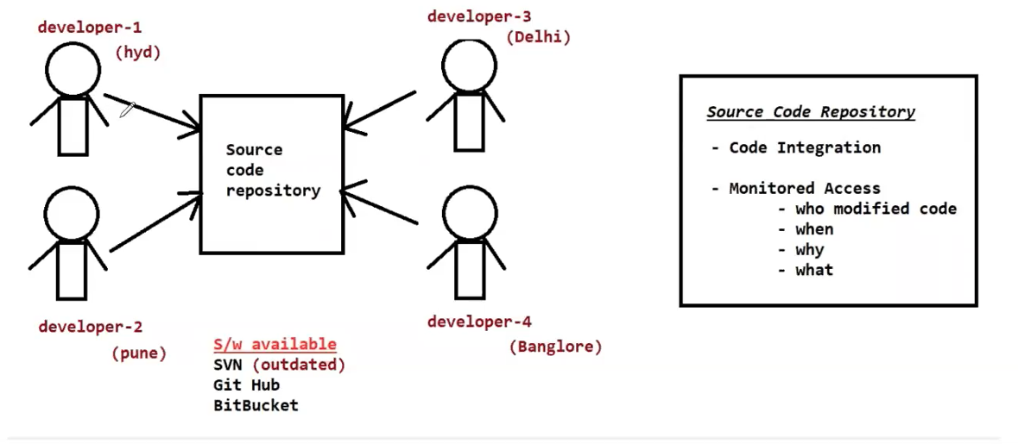

Advantages with Source code repository softwares
1) All the developers can connect to repository server and can integrate the code

2) Repository server will provide monitored access

- Who
- When
- Why
- What

Repository Tools

SVN (outdated)
Git Hub
Bit Bucket

Environment Setup to work with Git Hub

1) Create Github account ( www.github.com )

2) Download and install Git Client software ( https://git-scm.com/downloads )

3) Once installation completed, right click on the mouse and verify git options display (If git options displaying our git client installation completed successfully)

Working with GitHub
-> Login into github account with your credentials

-> Create Repository in github

Note: Repository is used to store project source code. Every Project will have one repository

-> When we create a repository, unique URL will be generated with Repository Name (i.e Repo URL)

-> All the developers will connect to repository using Repository URL

-> We can create 2 types of Repositories in Git Hub

1) public repository

2) private repository

-> Public Repository means everybody can access but we can choose who can modify our repository

-> Private Repository means we will choose who can access and who can modify

Repo URL : https://github.com/mmbabu0705/nexus-document.git

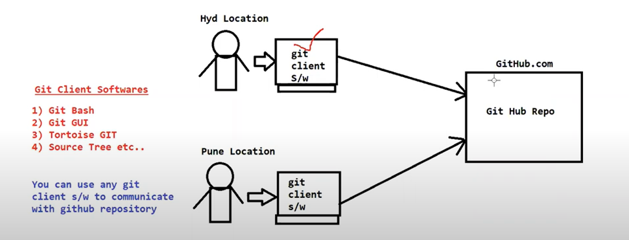

Working with Git Bash

-> Git Bash we can use as Git Client software to perform Git Operations

-> Download and install git client (https://git-scm.com/downloads)

-> Right Click on Mouse and choose "Open Git Bash Here"

git help : It will display frequently used git commands

git help <cmd-name> : It will open documentation for given command

Configure Your Email and Name in GitBash with Commands
+++++++++++++++++++++++++++++++++++++++++++++++++++++++++
$ git config --global user.email "youremail@yourdomain.com"

$ git config --global user.name "name"

$ git init : To initialize our folder as git working tree folder

$ git clone : To clone git repository to our machine from github.com

Syntax : $ git clone <project-repo-url>

$ git status : It will display staged , un-staged and un-tracked files

Syntax : $ git status

Staged Files : The files which are added for commit

Un-Staged Files : The files which are modified but not added for commit

Un-tracked files : Newly created files

Note: To commit a file(s), we should add to staging area first

$ git add : It is used to add file(s) to staging area

Syntax : $ git add <file-name>

$ git add .

$ git commit : It is used to commit staged files to git local repository

Syntax : $ git commit -m 'reason for commit'

$ git push : To push changes from git local repository to git central repository

Syntax : $ git push

Steps to push code to github central repository
++++++++++++++++++++++++++++++++++++++++++++++++

1) Create one public repository in git hub (take github repo url)

2) Clone github repository using 'git clone' command

$ git clone 'repo-url'

3) Navigate to repository folder

4) Create one file in repository folder

$ touch Demo.java

5) Check status of the file using 'git status' command

$ git status (It will display as untracked file)

6) Add file to staging area using 'git add' command

$ git add .

7) Commit file to git local repository

$ git commit -m 'commit-msg'

8) Push file from git local repository to git central repository using 'git push' command

$ git push

Note: If you are doing 'git push' for first time it will ask to enter your github account password.

------------------------------------------------------------------------------------------------------------------
Note: Git bash will ask our password only for first time. It will save our git credentials in Credential Manager in Windows machine.

-> Go to Credential Manager -> Windows Credentials -> Select Github -> We can modify and delete saved credentials from here
------------------------------------------------------------------------------------------------------------------

-> When we do git commit then it will geneate a commit-id with 40 characters length

-> From this commit-id it will display first 7 characters in git hub central repository

-> We can check commit history using 'git log' command

---------------------------------------------------------------------------------------------------------------------
Steps to commit Maven Project to Github Repository
---------------------------------------------------------------------------------------------------------------------

1) Create Maven Project

2) Create GitHub Repository

Note: After creating git repository, it will display set of commands to execute

3) Open gitbash from project folder and execute below commands

$ git init
$ git status
$ git add .
$ git commit -m 'commit-msg'
$ git branch -M main
$ git remote add origin <repo-url>
$ git push -u origin master

--------------------------------------------------------------------------------------------------------------------
git help
git config
git init
git status
git add .
git restore
git commit -m 'msg'
git push
git clone
git log
git remote add
--------------------------------------------------------------------------------------------------------

When we are working on one task suddenly we may get some other priority task.

Usecase
++++++++
->Manger assigned task id : 101
-> I am working on that task (i am in middle of the task)
-> Managed told that stop the work for 101 and complete 102 on priority.
-> Once 102 is completed then resume your work on 101

-> When manager asked me to start 102 task, i have already done few changes for 101
(partially completed)

-> We can't push partial changes to repository because with our partial changes existing functionality may break.

-> We can't delete our changes because we have spent few hours of time to implement those changes

*************** In this scenario we will go for 'git stash' option *********************

=> Git stash is used to save working tree changes to temporary location and make working tree clean.

-> After priority work completed we can get stashed changes back using 'gitstash apply'

===================================================================================================================
Git Branches
==================================================================================================================

-> Branches are used to maintain seperate code bases for our project

-> In GiT repository we can create multiple branches

main
develop
qa
release
research

-> development team will integrate the code in 'develop' branch

-> bug-fixing team will integrate the code in 'qa' branch

-> R & D team will integrate the code in 'research' branch

-> In github we can create branches

-> To clone particular branch in git repo we will use below command

$ git clone -b <branch-name> <repo-url>

------------------------------------------------------------------------------------------------------------------

What is Git branch ?

Why we need git branches ?

How to create git branches ?

How to clone particular branch

How to switch from one branch to another branch

-------------------------------------------------------------------------------------------------------------------
Branch Merging
---------------------------------------------------------------------------------------------------------------------

=> The process of merging changes from one branch to another branch is called as Branch merging

=> We will use Pull Request for Branch Merging

Steps to do branch merging
++++++++++++++++++++++++++

1) Create feature branch from main branch

2) clone feature branch

3) create new file in feature branch then commit and push to central repo

4) Go to central repository then create pull request to merge feature branch changes to main branch

Note: Once feature branch changes are merged to main branch then we can delete feature branch (if required)

---------------------------------------------------------------------------------------------------------------------
What is .gitignore ?
---------------------------------------------------------------------------------------------------------------------

-> This .gitignore is used to configure the files or folders which we want to ignore from our commits

-> The files and folders which are not required to commit to central repository those things we can configure in .gitnore file

Ex: In maven project 'target' folder will be available which is not required to commit to central repository. This we can configure in .gitignore file.

---------------------------------------.gitignore-------------------------------------------------------
HELP.md
target/
!.mvn/wrapper/maven-wrapper.jar
!**/src/main/**/target/
!**/src/test/**/target/

### STS ###
.apt_generated
.classpath
.factorypath
.project
.settings
.springBeans
.sts4-cache

### IntelliJ IDEA ###
.idea
*.iws
*.iml
*.ipr

### NetBeans ###
/nbproject/private/
/nbbuild/
/dist/
/nbdist/
/.nb-gradle/
build/
!**/src/main/**/build/
!**/src/test/**/build/

### VS Code ###
.vscode/

--------------------------------------------------------------------------------------------------
git merge vs git rebase
--------------------------------------------------------------------------------------------------

=> These commands are used to merge changes from one branch to another branch

-> git merge will maintain commit history

-> git rebase will not maintain that rebase history

-> When we are working on particular sprint and we want to merge changes from one branch to another branch then we will use 'git merge' command

-> Once sprint-1 is delivered then we want to take latest code of sprint-1 to start sprint-2 development. In this scenario we don't need commit history so we will use 'git rebase' command.

--------------------------------------------------------------------------------------------------------------What is git pull command
--------------------------------------------------------------------------------------------------------------

-> pull command is used to take latest changes from repository to local

-> When we want to make some changes to code, it is always recommended to take git pull

Note: When we execute 'git pull' there is a chance of getting conflicts. We need to resolve the conflict and we should push the code without conflicts.

--------------------------------------------------------------------------------------------------
What is Source Code repository
Why we need source code repository
What are the source code repository servers available
What is Code Integration
What is Monitored Access
What is git hub
What is git
What is version control
What is Repository
Public Repository vs Private Repository
Cloning Repository
Staged vs Unstaged vs Untracked File
Adding Files to Stating Area
Unstaging the files from staging
Discarding local changes
What is working tree
What is Local Repostiory
What is Central Repository
Commit from working tree to local repo
push from local repo to central repo
Taking latest code changes
push vs pull
What is conflict
How to resolve conflicts
What is branch in git hub
How to create branches
How to clone particular branch
how to switch to particular branch
How to merge branches
What is pull request
git merge vs rebase
what is .gitignore

git init
git help
git config
git clone
git status
git add .
git add <file-name>
git restore
git commit
git push
git pull
git log
git rm
git branch
git checkout
git merge
git rebase
--------------------------------------------------------------------------------------------------
Assignment
--------------------------------------------------------------------------------------------------

**Assignment**

1) Create Maven Web Application
2) Added 'Spring-Core' dependency in project pom.xml file
3) Package maven project as war file using maven goal
4) Create Git repository in github.com (public repo)
5) Push maven project into github repo using gitbash
(target folder shouldn't be commited, add this is .gitignore file)
6) Make changes in pom.xml and push changes to github repo using git bash
7) Create 'feature' branch in git repo from main branch
8) Clone feature branch from git bash using git clone
9) Make changes in 'feature' branch pom.xml file and push changes to central repo
10) Create pull request and merge 'feature' branch changes to 'main' branch

